PHOTOGRAPHIC FIELD TRIP REPORT
AUGUST 2021

The Field Trip consisted of two groups.

Peter Facy, Ian Jackson and Peter Wilson carried out the surface photographing of existing vegetation sites while Phil Prust, Brian and Gill McKay flew the drone to photograph selected vegetation sites from the air, Bill Dowling “floated” between the two groups as required.

We all met in the Foreshore Hotel at Ceduna for dinner on Monday 23rd and left the following morning after meeting with Brett Backhouse and other staff at the Ceduna office.

There were 77 vegetation sites scheduled to be visited along the Lake Dey Dey road, the Dey Dey road north of Oak Valley, the business road to the border of WA, the two BMR roads (north/south and the northern east/west one) and the Voakes Hill – Cook Road.

There were only three campsites used, the Irish Well site for 2 nights, the corner of the Cook Road and the business roads for 4 nights and the corner of the BMR and the business roads for 3 nights. This allowed us to reduce the daily driving distances to the sites and kept moving camps to a minimum.

We were able to photograph 68 sites. 3 sites on the NE road from Irish Well and 3 on the Dey Dey road north of Oak Valley are no longer able to be reached due to the overgrown road. We also were not able to reach 3 sites south of Immarna siding east of Ooldea as the railways now prohibit the use of their maintenance roads.

The Drone team were able to photograph 37 sites. Some of those not photographed were protected sites which are now off limits and some could not be photographed due to wind conditions and time constraints.

One of the highlights of the trip was the increased rapport the Friends have developed with the local community at Oak Valley. In particular, with Sam Doudle (Ranger Co-Ordinator at Oak Valley), her husband Shane (Ranger) and Jeremy LeBois, chair of the Maralinga Tjarutja Trust.

Three days into the trip Sam drove 52 kms to our camp to lend us a satellite phone which allowed us to keep in contact as Oak Valley had been closed during a COVID scare at Ceduna and Nundroo where we had refuelled. While this was done primarily to safeguard the Oak Valley community, we were impressed with this effort to help us.

When the COVID scare was reduced, we were invited to Oak Valley for a BBQ while Ian and I were accompanied by Shane and a number of community residents north on the Dey Day road to photograph 6 sites.

We returned to Ceduna after the last camp on the Irish Well road on Thursday 2nd of September to a closing dinner at the Foreshore Hotel.

The trip was a great success and enjoyed by all members. It was unfortunate that the “Quandong Trip”, which was to overlap us, could not take place due to the COVID restrictions.

Peter Facy
Trip Leader
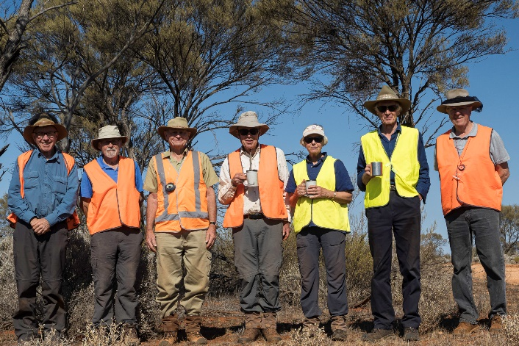 | 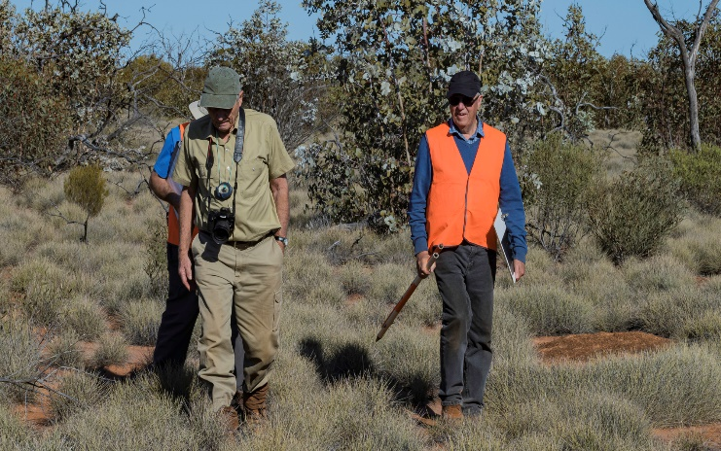
The photopoint team | Photopoint site with the rare Eucalyptus wyolensis
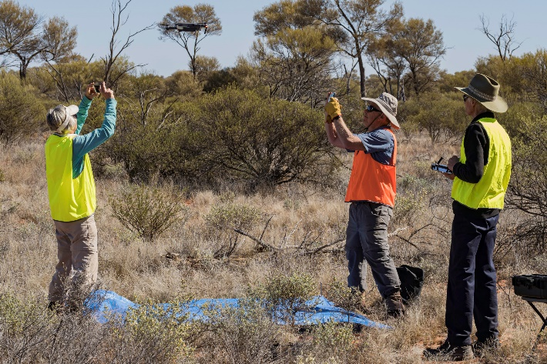 | 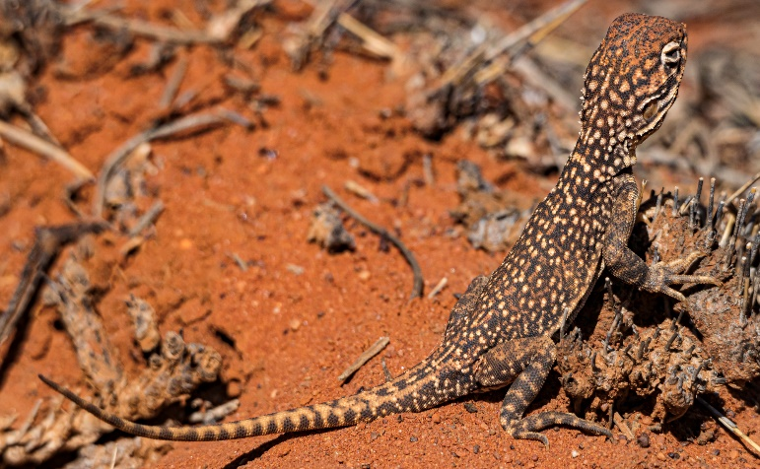
Flying the vegetation survey drone | Lizard on BMR 4
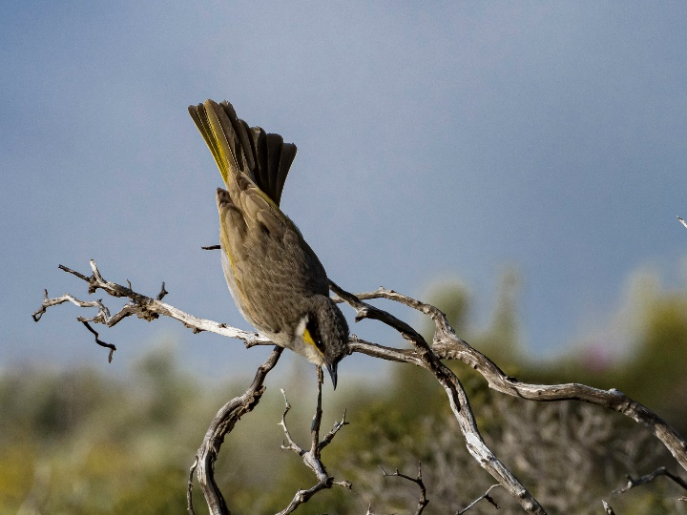 | 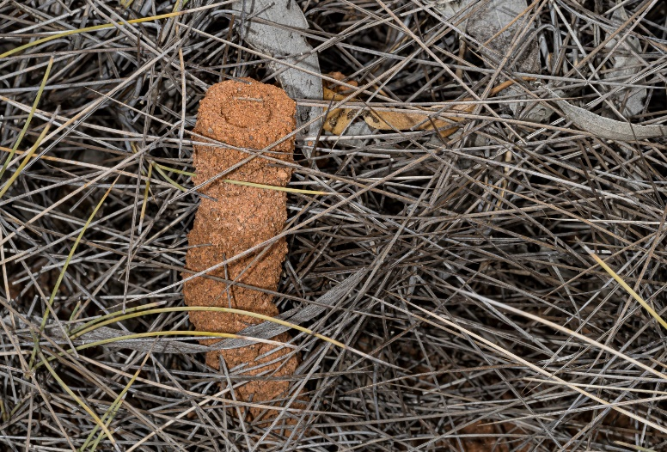
Singing Honeyeater taking off | Spinifex Ant nest

